|  |
| --- |
| Saviynt Failures Management – Design Document  February 2023 |
|  |
|  |
|  |

**Table of Contents**

Document Control 3

Introduction 3

Purpose 3

Saviynt Task Statuses 3

Dashboards 4

Tasks that failed today 4

Tasks that failed this week 6

Tasks that failed this month 8

Failed Tasks by Application 10

Completed Failed Tasks 12

Discontinued Failed Tasks 14

Required SAV Role 16

WSRetry Provisioning Job 17

# Document Control

|  |  |  |  |
| --- | --- | --- | --- |
| **Version control** | | | |
| **Version** | **Name** | **Role** | **Date** |
| v1 | Kunal Saxena | Author | 12/20/2022 |
| v2 | Vineet Gupta | Author | 01/15/2023 |
| v3 | Gaurav Khandelwal | Author | 02/09/2023 |

# Introduction

This design document covers the dashboards created in Saviynt for monitoring failed tasks

## Purpose

The purpose of this document is to provide details about the dashboards created in Saviynt for monitoring failed tasks. The document would cover the analytics, metrics and data points used by the various dashboards as well as how the manual team can use these dashboards for tracking and processing failed tasks

# Saviynt Task Statuses

* **New** - A newly created task is initially assigned the status as "New" before it is processed further
* **Completed** - A task is assigned the status as "Completed":

1. Once the system has finished processing the task by fulfilling the required action (for connected applications)
2. User marks the task as "Completed" in Saviynt after manually completing the action (for disconnected applications OR failed tasks that are processed manually)

* **Discontinued** - A user can mark a task's status as "Discontinued" from the tasks page under ARS in Saviynt
* **Error** - Task status is marked as "Error" when:

1. There is a system error, or an exception raised while processing the task

b. The task has failed for successive retries and the no of retry attempts has increased the failed tries threshold

* **STATUS_NO_ACTION_REQUIRED** - Status assigned to task when no action required to be executed by system. Examples:

1. Account Key already exists for the account name for an "Add Account" task
2. Entitlement already assigned to the account for an "Add Access" task

* **In Progress** - Task is marked as "In Progress" when it is claimed by a user. A task can be claimed from the tasks page under ARS, using the Claim button:
* **Pending Provisioning** – Task status is "Pending Provisioning" when provisioning needs to happen via a ticket (ServiceNow ITSM)

# Dashboards

The implementation is as follows:

## Tasks that failed today

**Dashboard Type** – Tile

**Description** – This dashboard displays the count of tasks that have failed today in the Saviynt system

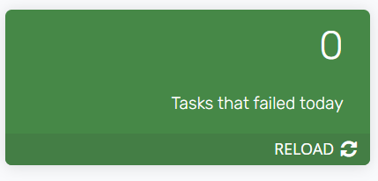

*Figure 1a: Dashboard for a given day when there no failed tasks*

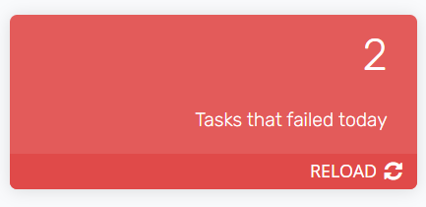

*Figure 1b: Dashboard for a given day when there are 2 failed tasks*

**Criteria for identifying failed tasks -** TASKS.PROVISIONINGTRIES IS NOT NULL **AND** TASKS.PROVISIONINGTRIES >= 1 **AND** TASKS.STATUS IS NOT (‘Completed’, ‘Discontinued’, ‘Error’, ‘STATUS_NO_ACTION_REQUIRED’)

**Action** – Clicking on the dashboard will direct the user to the Analytics page

**Analytics Detail**

**Name** – Daily failed tasks

**Description** – This analytics report shows all the tasks that have failed today in Saviynt system

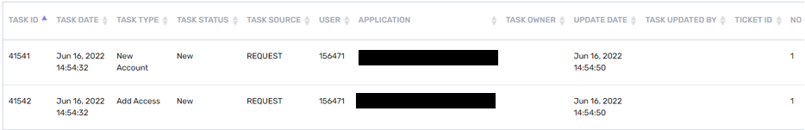

**Columns** –

|  |  |
| --- | --- |
| **Column Name** | **Description** |
| TASK ID | ID of the task in Saviynt DB |
| TASK DATE | Date when the task was created |
| TASK TYPE | Type of task - "new account", "add access" etc. |
| TASK STATUS | Status of task - "new", "in progress", "completed" etc. |
| TASK SOURCE | Source in Saviynt which created the task |
| USER | User ID for which this task was created |
| APPLICATION | Application associated to this task. Action performed by this task would be associated to this application |
| TASK OWNER | Name of the owner of this task. This can also be the user who claimed the task |
| UPDATE DATE | Date when the task was last updated |
| TASK UPDATED BY | Name of the user who last updated the task |
| TICKET ID | Ticket ID, if any associated with this task |
| NO OF TIME RETRIED | Count of the times this task was retried by the system after failing initially |
| COMMENT | Comment added to task |
| PROVISIONING COMMENTS | Any provisioning comments added to task |

**Actions** –

* **Filtering** – User has the option to filter the results in the report using the filtering controls located on the left pane of the screen. Results can be filtering by a single metric or a combination of metrics by selecting a value within a given metric. For example, results can be filtered by task type:

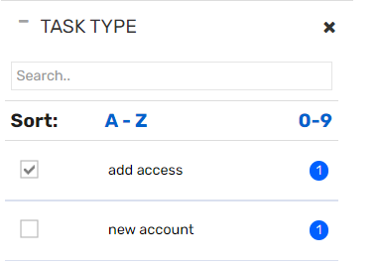

Failed tasks with task type = “add access” will be displayed on the report

* **Export** – User can export the analytics report as an excel or a csv file, using the Actions button

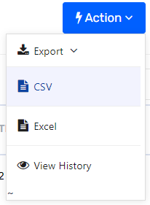

* **Columns** – User can show/hide columns in the analytics report using the Columns button and selecting or de-selecting the columns from the drop-down:

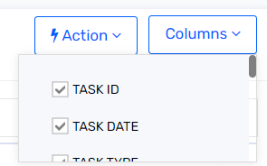

## Tasks that failed this week

**Dashboard Type** – Tile

**Description** – This dashboard displays the count of tasks that have failed in the current week in the Saviynt system

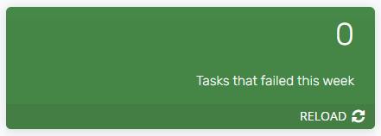

*Figure 2a: Dashboard for a week when there no failed tasks*

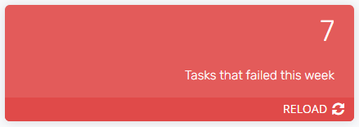

*Figure 2b: Dashboard for a week when there are 7 failed tasks*

**Criteria for identifying failed tasks -** TASKS.PROVISIONINGTRIES IS NOT NULL **AND** TASKS.PROVISIONINGTRIES >= 1 **AND** TASKS.STATUS IS NOT (‘Completed’, ‘Discontinued’, ‘Error’, ‘STATUS_NO_ACTION_REQUIRED’)

**Action** – Clicking on the dashboard will direct the user to the Analytics page

**Analytics Detail**

**Name** – Weekly failed tasks

**Description** – This analytics report shows all the tasks that have failed in the current week in Saviynt system

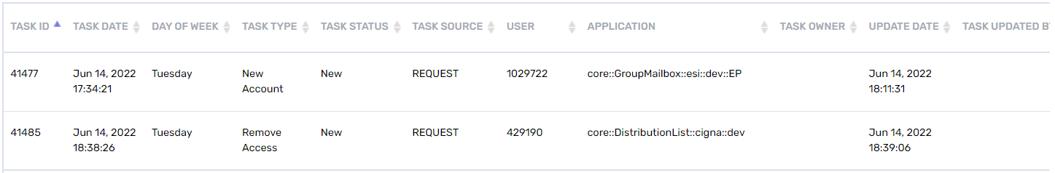

**Columns** –

|  |  |
| --- | --- |
| **Column Name** | **Description** |
| TASK ID | ID of the task in Saviynt DB |
| TASK DATE | Date when the task was created |
| DAY OF WEEK | Day of the week - "Monday", "Tuesday" etc. |
| TASK TYPE | Type of task - "new account", "add access" etc. |
| TASK STATUS | Status of task - "new", "in progress", "completed" etc. |
| TASK SOURCE | Source in Saviynt which created the task |
| USER | User ID for which this task was created |
| APPLICATION | Application associated to this task. Action performed by this task would be associated to this application |
| TASK OWNER | Name of the owner of this task. This can also be the user who claimed the task |
| UPDATE DATE | Date when the task was last updated |
| TASK UPDATED BY | Name of the user who last updated the task |
| TICKET ID | Ticket ID, if any associated with this task |
| NO OF TIME RETRIED | Count of the times this task was retried by the system after failing initially |
| COMMENT | Comment added to task |
| PROVISIONING COMMENTS | Any provisioning comments added to task |

**Actions** –

* **Filtering** – User has the option to filter the results in the report using the filtering controls located on the left pane of the screen. Results can be filtering by a single metric or a combination of metrics by selecting a value within a given metric. For example, results can be filtered by task type:



Failed tasks with task type = “add access” will be displayed on the report

* **Export** – User can export the analytics report as an excel or a csv file, using the Actions button



* **Columns** – User can show/hide columns in the analytics report using the Columns button and selecting or de-selecting the columns from the drop-down

## Tasks that failed this month

**Dashboard Type** – Tile

**Description** – This dashboard displays the count of tasks that have failed in the current month in the Saviynt system

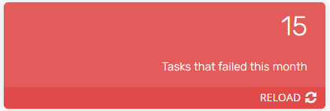

*Figure 3a: Dashboard for current month with 15 failed tasks*

**Criteria for identifying failed tasks -** TASKS.PROVISIONINGTRIES IS NOT NULL **AND** TASKS.PROVISIONINGTRIES >= 1 **AND** TASKS.STATUS IS NOT (‘Completed’, ‘Discontinued’, ‘Error’, ‘STATUS_NO_ACTION_REQUIRED’)

**Action** – Clicking on the dashboard will direct the user to the Analytics page

**Analytics Detail**

**Name** – Monthly failed tasks

**Description** – This analytics report shows all the tasks that have failed in the current month in Saviynt system

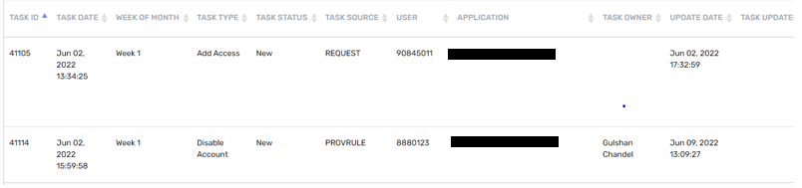

**Columns** –

|  |  |
| --- | --- |
| **Column Name** | **Description** |
| TASK ID | ID of the task in Saviynt DB |
| TASK DATE | Date when the task was created |
| WEEK OF MONTH | Day of the week - "Monday", "Tuesday" etc. |
| TASK TYPE | Type of task - "new account", "add access" etc. |
| TASK STATUS | Status of task - "new", "in progress", "completed" etc. |
| TASK SOURCE | Source in Saviynt which created the task |
| USER | User ID for which this task was created |
| APPLICATION | Application associated to this task. Action performed by this task would be associated to this application |
| TASK OWNER | Name of the owner of this task. This can also be the user who claimed the task |
| UPDATE DATE | Date when the task was last updated |
| TASK UPDATED BY | Name of the user who last updated the task |
| TICKET ID | Ticket ID, if any associated with this task |
| NO OF TIME RETRIED | Count of the times this task was retried by the system after failing initially |
| COMMENT | Comment added to task |
| PROVISIONING COMMENTS | Any provisioning comments added to task |

**Actions** –

* **Filtering** – User has the option to filter the results in the report using the filtering controls located on the left pane of the screen. Results can be filtering by a single metric or a combination of metrics by selecting a value within a given metric. For example, results can be filtered by task type:



Failed tasks with task type = “add access” will be displayed on the report

* **Export** – User can export the analytics report as an excel or a csv file, using the Actions button



* **Columns** – User can show/hide columns in the analytics report using the Columns button and selecting or de-selecting the columns from the drop-down

## Failed Tasks by Application

**Dashboard Type** – Pie

**Description** – This dashboard displays the failed tasks by application as a Pie Chart. Each slice of the pie represents an application in the system for which there are 1 or more failed tasks.

Dashboard contains a local filter to filter the Pie chart for a particular application. Clicking on the Application drop-down lists down all the applications that have failed tasks. Clicking on a particular application will filter the Pie Chart with data for that application

**Criteria for identifying failed tasks -** TASKS.PROVISIONINGTRIES IS NOT NULL **AND** TASKS.PROVISIONINGTRIES >= 1 **AND** TASKS.STATUS IS NOT (‘Completed’, ‘Discontinued’, ‘Error’, ‘STATUS_NO_ACTION_REQUIRED’)

**Action** – Clicking on the dashboard will direct the user to the Analytics page

**Analytics Detail**

**Name** – Failed Tasks Dashboard

**Description** – This analytics report shows all the failed tasks in the system. Report also contains the application for which a task has failed.

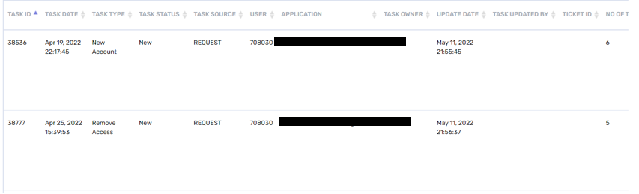

**Columns** –

|  |  |
| --- | --- |
| **Column Name** | **Description** |
| TASK ID | ID of the task in Saviynt DB |
| TASK DATE | Date when the task was created |
| TASK TYPE | Type of task - "new account", "add access" etc. |
| TASK STATUS | Status of task - "new", "in progress", "completed" etc. |
| TASK SOURCE | Source in Saviynt which created the task |
| USER | User ID for which this task was created |
| APPLICATION | Application associated to this task. Action performed by this task would be associated to this application |
| TASK OWNER | Name of the owner of this task. This can also be the user who claimed the task |
| UPDATE DATE | Date when the task was last updated |
| TASK UPDATED BY | Name of the user who last updated the task |
| TICKET ID | Ticket ID, if any associated with this task |
| NO OF TIME RETRIED | Count of the times this task was retried by the system after failing initially |
| COMMENT | Comment added to task |
| PROVISIONING COMMENTS | Any provisioning comments added to task |

**Actions** –

* **Filtering** – User has the option to filter the results in the report using the filtering controls located on the left pane of the screen. Results can be filtering by a single metric or a combination of metrics by selecting a value within a given metric. For example, results can be filtered by task type:



Failed tasks with task type = “add access” will be displayed on the report

* **Export** – User can export the analytics report as an excel or a csv file, using the Actions button



* **Columns** – User can show/hide columns in the analytics report using the Columns button and selecting or de-selecting the columns from the drop-down

## Completed Failed Tasks

**Dashboard Type** – Pie

**Description** – This dashboard displays the failed tasks grouped by Task Type, that are in “**Completed**” Status

Each slice of the pie represents a Task Type (“New Account”, “Add Access” etc.).

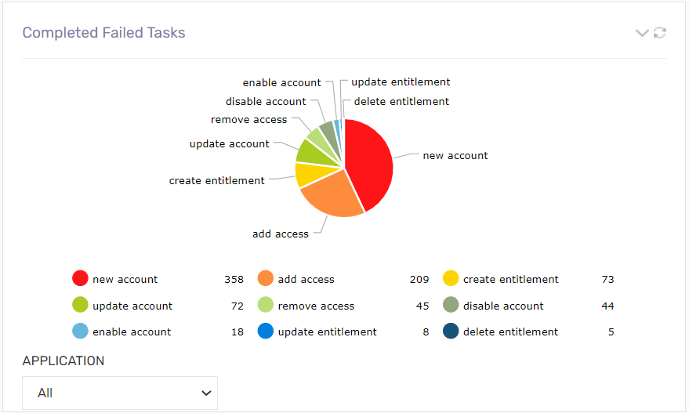

*Figure 7a: Dashboard containing Pie Chart for failed tasks that are in Completed status*

Dashboard contains a local filter to filter the Pie chart for a particular application. Clicking on the Application drop-down lists down all the applications that have failed tasks in “**Completed**” status. Clicking on a particular application will filter the Pie Chart with data for that application

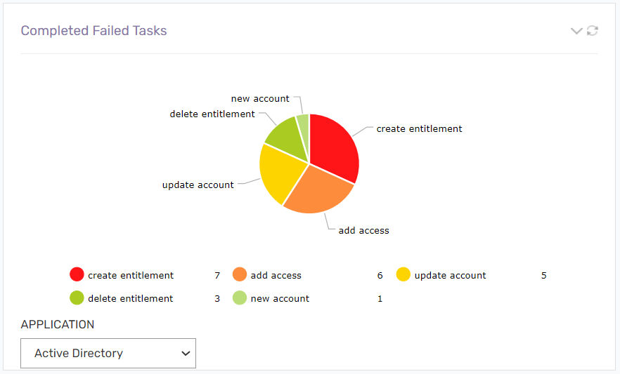

*Figure 7b: Dashboard containing Pie Chart for a particular application – Active Directory, selected from the local filter drop down*

**Criteria for identifying failed tasks -** TASKS.PROVISIONINGTRIES IS NOT NULL **AND** TASKS.PROVISIONINGTRIES >= 1 **AND** TASKS.STATUS = ‘Completed’ **AND** TASKS.UPDATEUSER IS NOT NULL

**Action** – Clicking on the dashboard will direct the user to the Analytics page

**Analytics Detail**

**Name** – Completed Failed Tasks

**Description** – This analytics report lists down all the failed tasks that are in “Completed” status

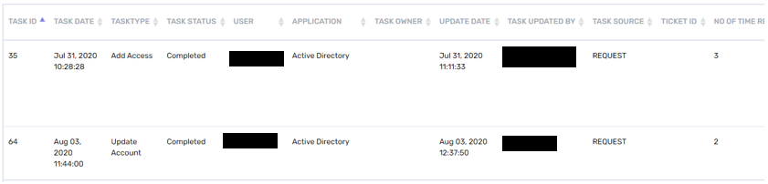

**Columns** –

|  |  |
| --- | --- |
| **Column Name** | **Description** |
| TASK ID | ID of the task in Saviynt DB |
| TASK DATE | Date when the task was created |
| TASK TYPE | Type of task - "new account", "add access" etc. |
| TASK STATUS | Status of task - "new", "in progress", "completed" etc. |
| USER | User ID for which this task was created |
| APPLICATION | Application associated to this task. Action performed by this task would be associated to this application |
| TASK OWNER | Name of the owner of this task. This can also be the user who claimed the task |
| UPDATE DATE | Date when the task was last updated |
| TASK UPDATED BY | Name of the user who last updated the task |
| TASK SOURCE | Source in Saviynt which created the task |
| TICKET ID | Ticket ID, if any associated with this task |
| NO OF TIME RETRIED | Count of the times this task was retried by the system after failing initially |
| COMMENT | Comment added to task |
| PROVISIONING COMMENTS | Any provisioning comments added to task |

**Actions** –

* **Filtering** – User has the option to filter the results in the report using the filtering controls located on the left pane of the screen. Results can be filtering by a single metric or a combination of metrics by selecting a value within a given metric. For example, results can be filtered by task type:



Failed tasks with task type = “add access” will be displayed on the report

* **Export** – User can export the analytics report as an excel or a csv file, using the Actions button



* **Columns** – User can show/hide columns in the analytics report using the Columns button and selecting or de-selecting the columns from the drop-down

## Discontinued Failed Tasks

**Dashboard Type** – Pie

**Description** – This dashboard displays the failed tasks grouped by Task Type, that are in “**Discontinued**” Status

Each slice of the pie represents a Task Type (“New Account”, “Add Access” etc.).

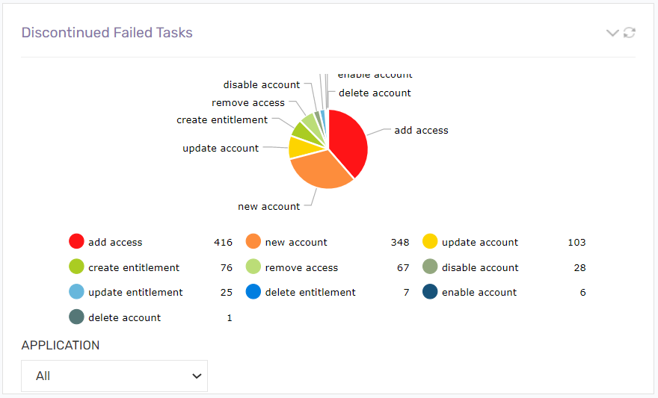

*Figure 6a: Dashboard containing Pie Chart for failed tasks that are in Discontinued status*

Dashboard contains a local filter to filter the Pie chart for a particular application. Clicking on the Application drop-down lists down all the applications that have failed tasks in “**Discontinued**” status. Clicking on a particular application will filter the Pie Chart with data for that application

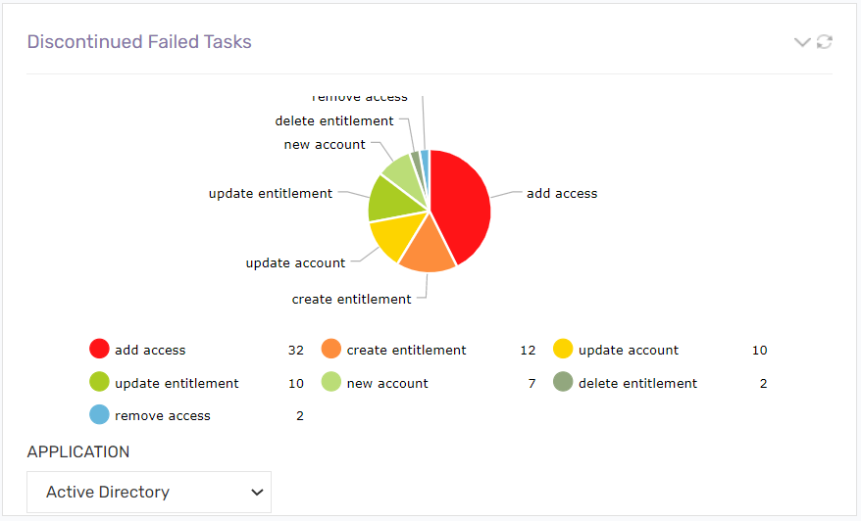

*Figure 6b: Dashboard containing Pie Chart for a particular application – Active Directory, selected from the local filter drop down*

**Criteria for identifying failed tasks -** TASKS.PROVISIONINGTRIES IS NOT NULL **AND** TASKS.PROVISIONINGTRIES >= 1 **AND** TASKS.STATUS = ‘Discontinued’ **AND** TASKS.UPDATEUSER IS NOT NULL

**Action** – Clicking on the dashboard will direct the user to the Analytics page

**Analytics Detail**

**Name** – Discontinued Failed Tasks

**Description** – This analytics report lists down all the failed tasks that are in “Discontinued” status

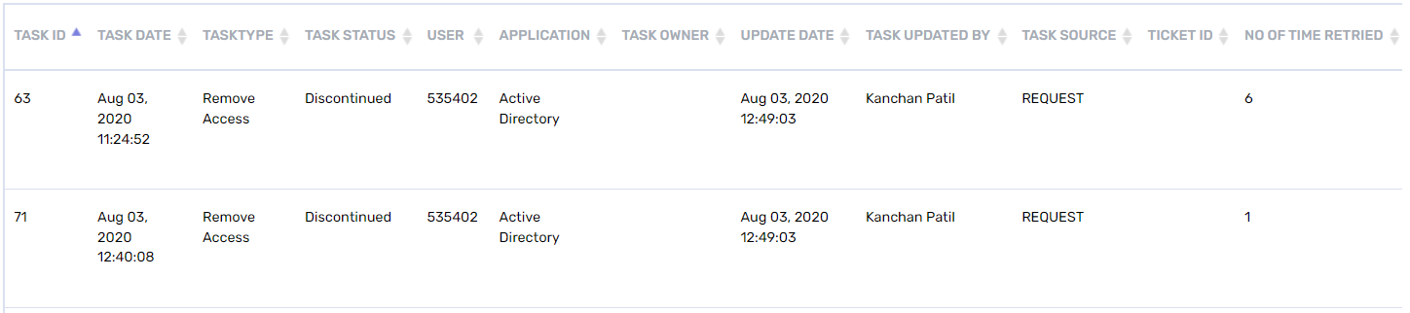

**Columns** –

|  |  |
| --- | --- |
| **Column Name** | **Description** |
| TASK ID | ID of the task in Saviynt DB |
| TASK DATE | Date when the task was created |
| TASK TYPE | Type of task - "new account", "add access" etc. |
| TASK STATUS | Status of task - "new", "in progress", "completed" etc. |
| USER | User ID for which this task was created |
| APPLICATION | Application associated to this task. Action performed by this task would be associated to this application |
| TASK OWNER | Name of the owner of this task. This can also be the user who claimed the task |
| UPDATE DATE | Date when the task was last updated |
| TASK UPDATED BY | Name of the user who last updated the task |
| TASK SOURCE | Source in Saviynt which created the task |
| TICKET ID | Ticket ID, if any associated with this task |
| NO OF TIME RETRIED | Count of the times this task was retried by the system after failing initially |
| COMMENT | Comment added to task |
| PROVISIONING COMMENTS | Any provisioning comments added to task |

**Actions** –

* **Filtering** – User has the option to filter the results in the report using the filtering controls located on the left pane of the screen. Results can be filtering by a single metric or a combination of metrics by selecting a value within a given metric. For example, results can be filtered by task type:



Failed tasks with task type = “add access” will be displayed on the report

* **Export** – User can export the analytics report as an excel or a csv file, using the Actions button



* **Columns** – User can show/hide columns in the analytics report using the Columns button and selecting or de-selecting the columns from the drop-down

# Required SAV Role

To allow access to the Failures Dashboard and Pending Tasks following SAV Roles will need to be granted to users who need access to these capabilities

* ROLE_Company_IDADMIN
* ROLE_TASKADMIN

# WSRetry Provisioning Job

To keep the failed tasks in Pending Tasks state and the provisioning Job will be updated to only try tasks that have Provisioning tries less than or equal to 4.

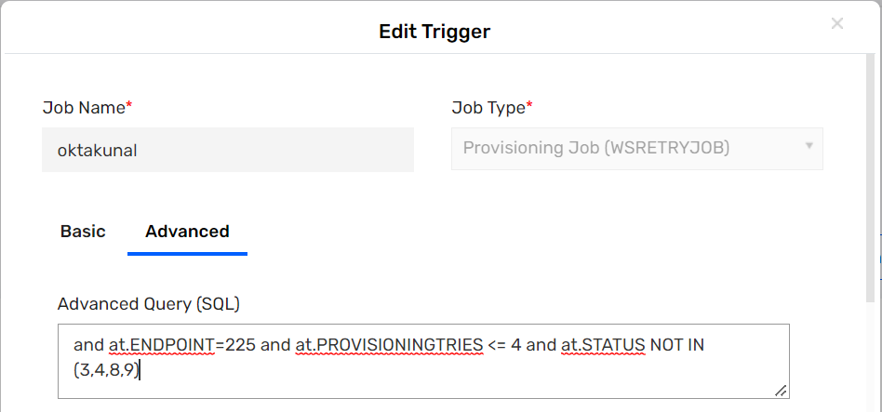

**Sample Query -** and at.ENDPOINT=225 and at.PROVISIONINGTRIES <= 4 and at.STATUS NOT IN (3,4,8,9)